**Geography 150 Lab 2: Part 1: Comparing cities and controls on temperature patterns.**

Monthly temperature and precipitation patterns for several US and world cities are provided below. Latitude and longitude, elevations for selected cities (Los Angeles, Yuma, Denver, St. Louis, Chicago, and Sitka), and a location on a small map are given. Answer the questions that follow by comparing the temperature charts, noting locations, and considering latitude, land and water contrasts, altitudes, and potentially the effects of wind or air masses (if known). *Note that locations at a similar latitude will have the same sun angles and day lengths through the year*. *Several charts are included for comparisons of temperature profiles.*

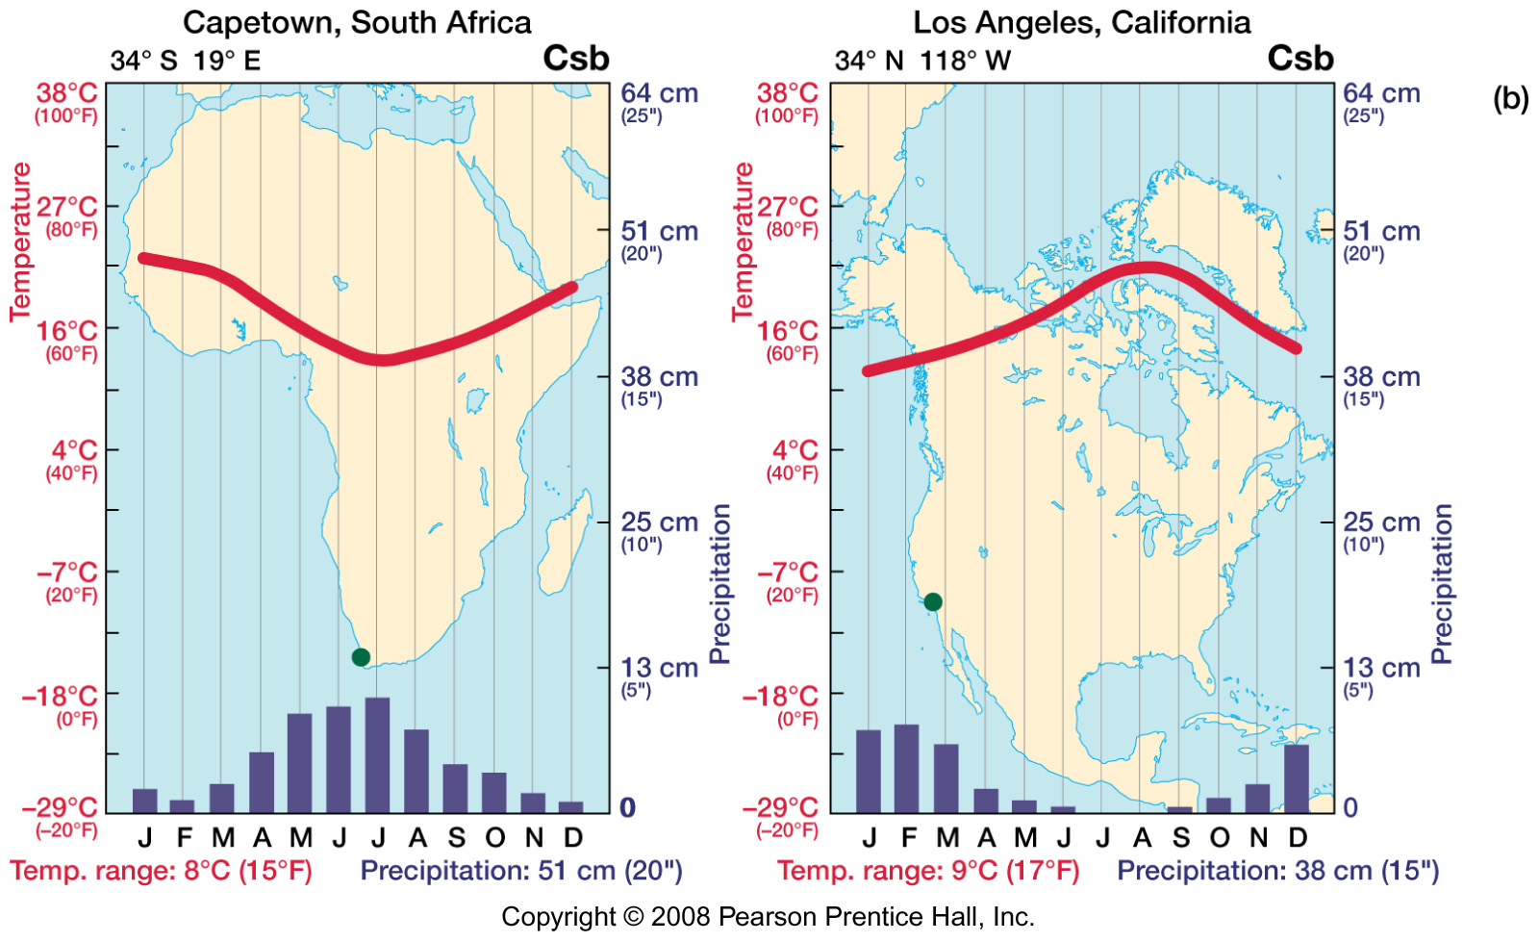

Los Angeles, CA: Elevation 285 feet (87 meters) average

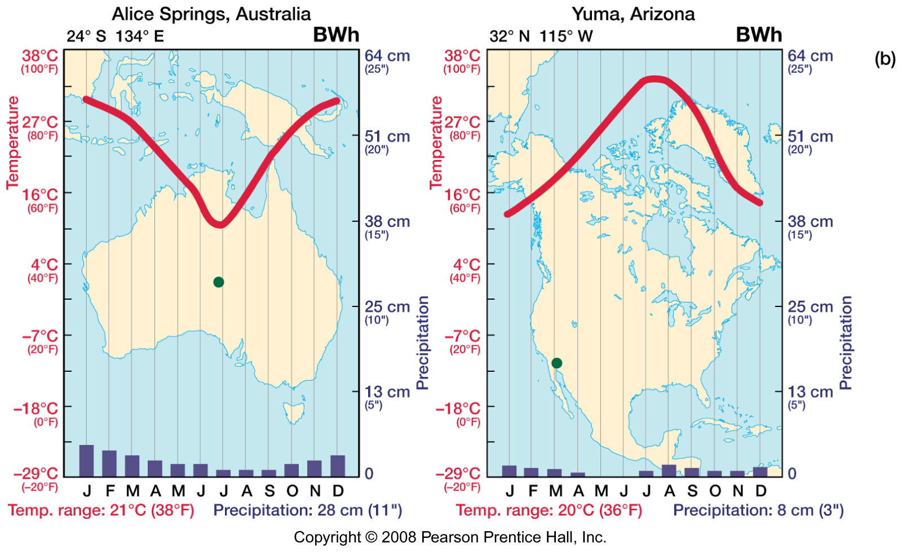

Yuma, AZ: Elevation 141 feet (42 meters)

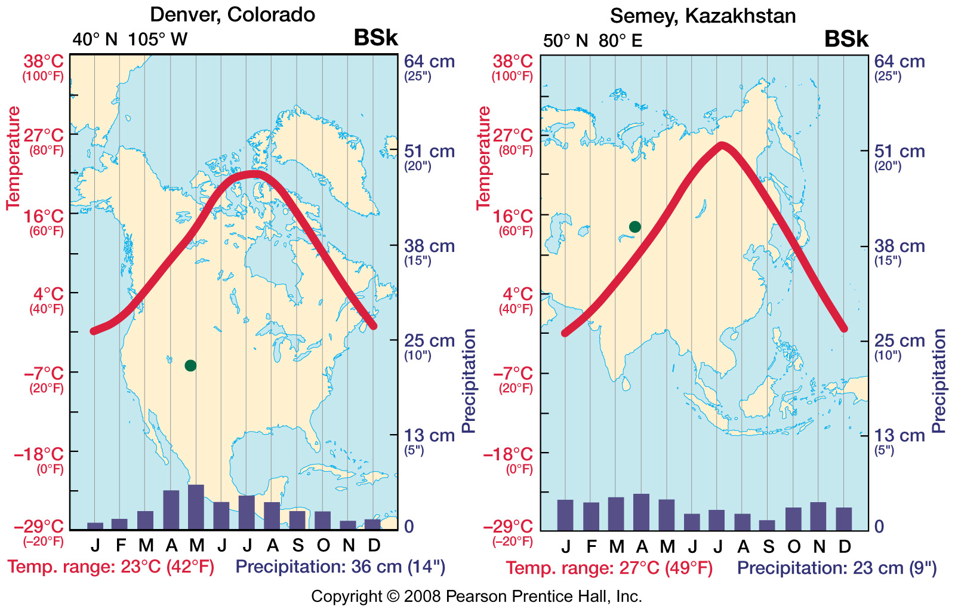

Denver, CO: Elevation 5280 feet (1609 meters)

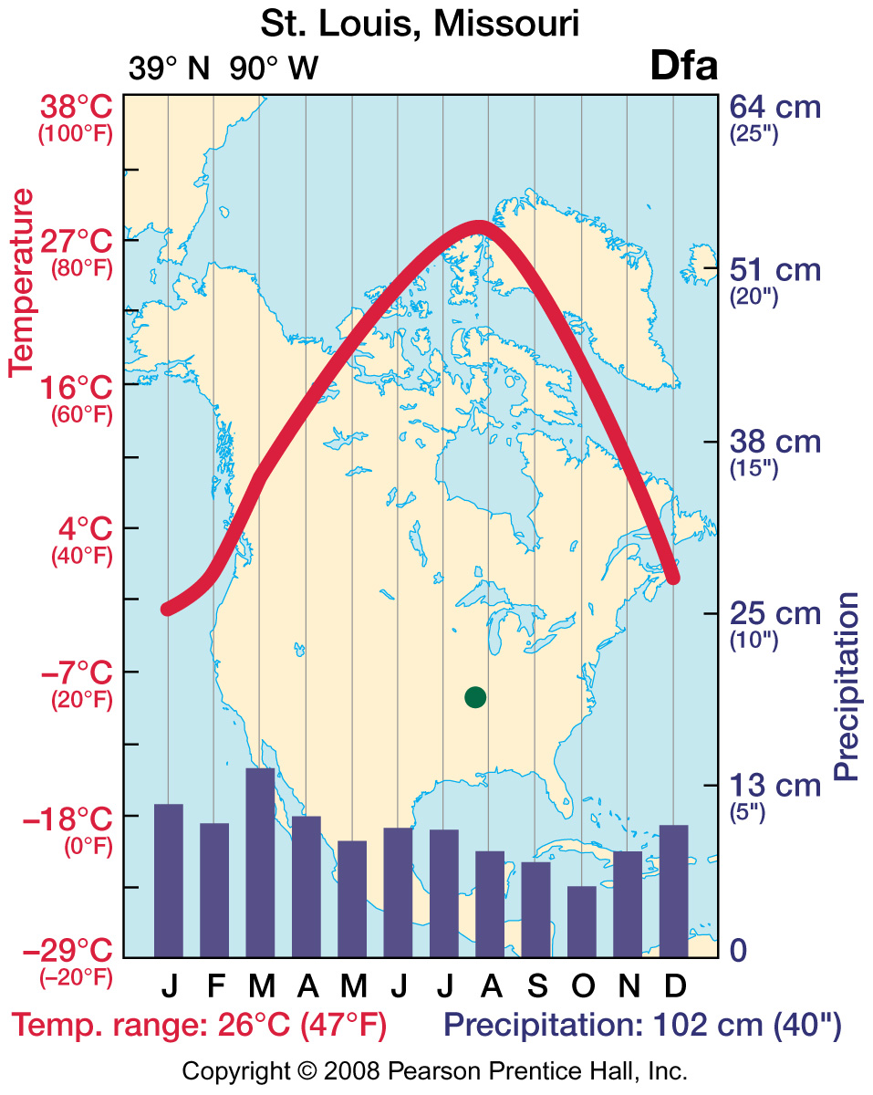

St. Louis, MO: Elevation 535 feet (133 meters)

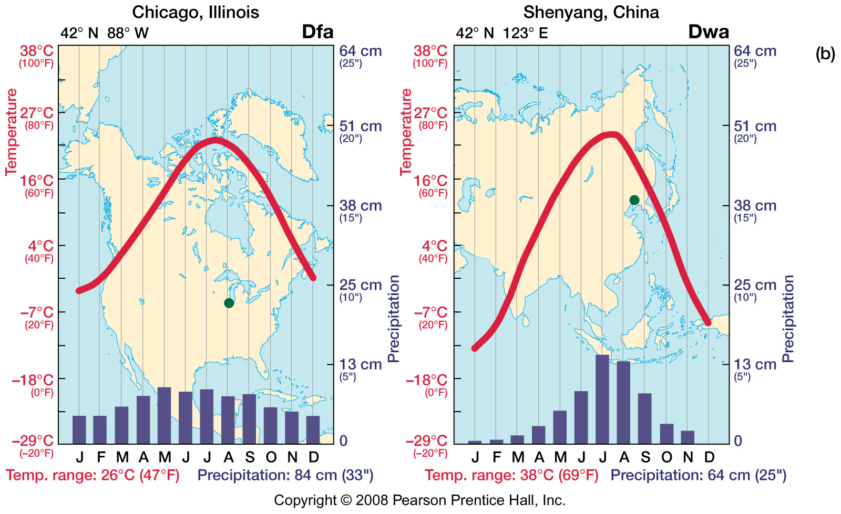

Chicago, Il: Elevation 594 feet (181 meters)

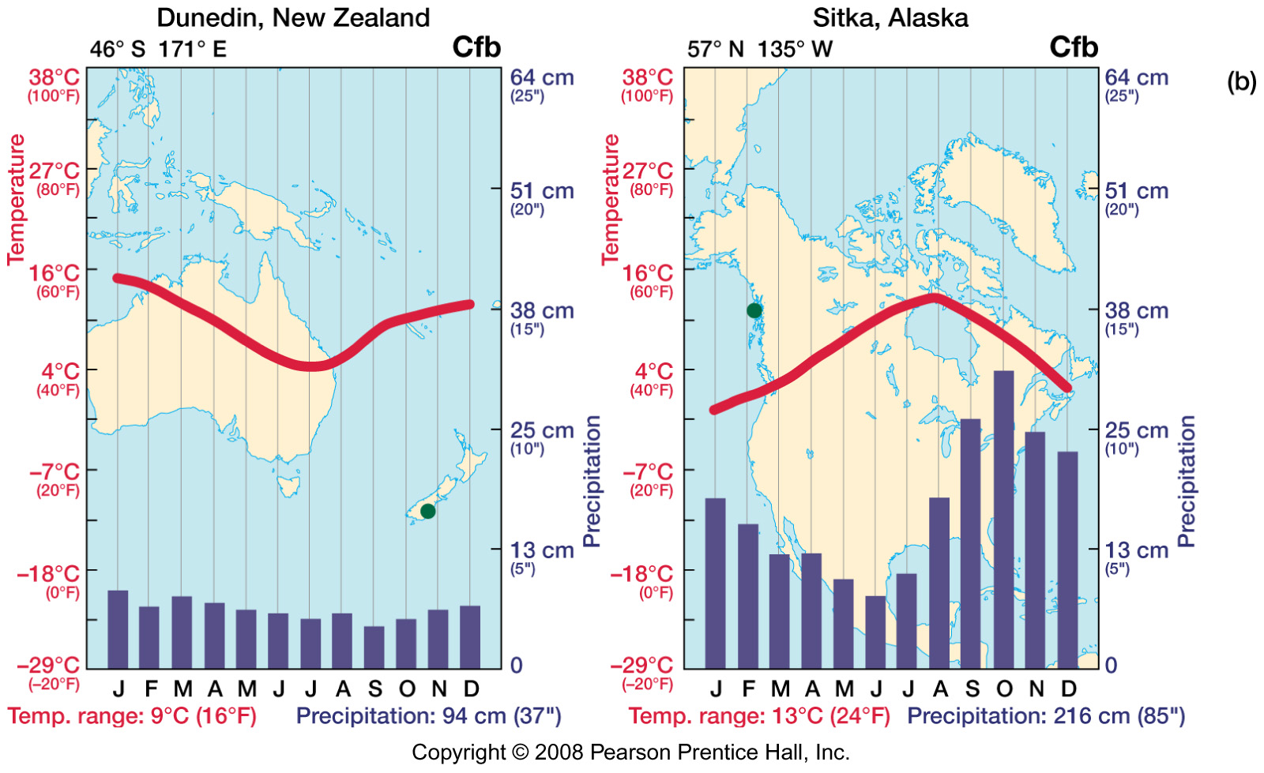

Sitka, AK: Elevation 26 feet (8 meters)

1. Why does Yuma, AZ have warmer summers than Los Angeles, CA?

Yuma is farther inland that Los Angeles and therefore doesn’t have the advantage of having a large body of water nearby to moderate the temperature, Yuma also sits at a lower elevation than Los Angeles which also plays a part in the warmer temperatures

1. Why does St. Louis, MO have warmer summers than Denver, CO?

St. Louis is at a significantly lower altitude than Denver is what I would say as to why St. Louis has warmer summers than Denver. The climates are considerably different also, St. Louis gets a lot more precipitation than Denver does as Denver is in more of an arid area of the United states

1. When compared to Sitka, AK, Chicago, Il has colder winters. Why? Note the latitude of each.

Sitka is at a higher latitude and ocean currents keep the temperatures pretty uniform, and Chicago is at a higher elevation and is inland away from the mitigating effects of the ocean currents

1. Why does Sitka have a smaller range of temperatures through the year than Chicago?

Sitka has a smaller range of temperature during the year in comparison to Chicago because of it’s positioning on the coast where the currents help to moderate the temperature extremes

1. Note the latitudes of Los Angeles, CA and Capetown, S. Africa. Explain the temperature profiles of each city and how they compare.

Los Angeles and Cape Town reside in basically the same latitude but in different hemispheres. Los Angeles is in the norther hemisphere and Cape Town is located in the southern hemisphere therefore their temperature profiles will be different such as in July in Los Angeles it is summer and in Cape Town it is the winter. Cape Town has a higher elevation than Los Angeles so it should be cooler in the summer and have milder winters.

1. Other pairings (above) are made for comparisons of climates of selected cities. Note that Chicago and Shenyang share the same latitude. Would you expect Sitka, AK and Dunedin, New Zealand to have similar ranges of temperature? Which of these two cities is at a higher latitude? Which of these two cities reaches cooler temperatures through the year?

I would expect Sitka and Dunedin to have similar ranges in temperature possibly due to their locations on the coast and the ocean. Sitka has the higher elevation. Sitka has the colder temperatures through out the year.

**Part 2: Using world maps of isotherms (lines of equal temperature) and a map of shallow ocean currents to examine climate and temperature patterns.**

The following questions are based on the figures (maps below) of average January sea level temperatures and average July sea level temperatures globally.

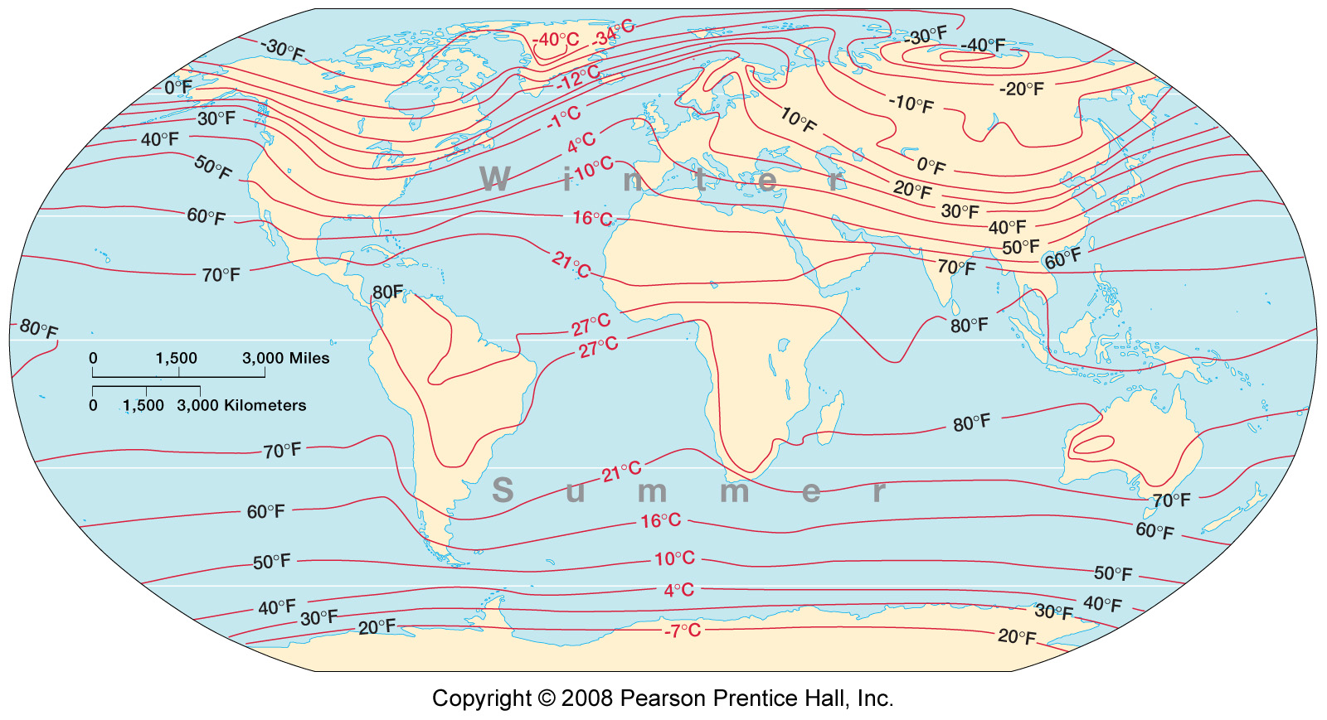

Figure 1: Average January sea level temperatures

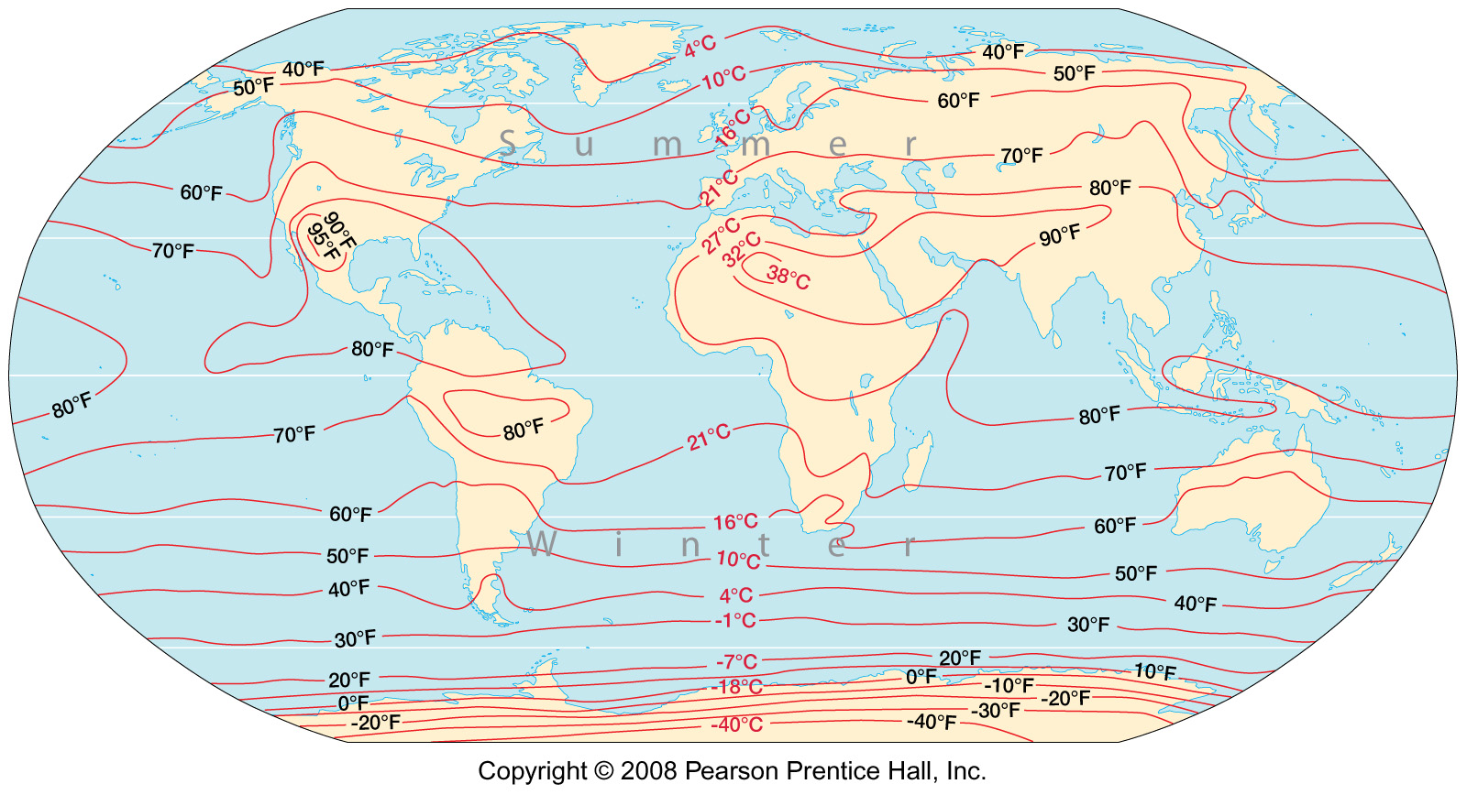

Figure 2: Average July sea level temperatures

Note also a reference map of the oceanic gyres; the large patterns of shallow ocean currents, driven by the Coriolis effect (below). The north Pacific gyre circulates in a clockwise direction, bring warmer ocean water northward in the western Pacific (Kuroshio current on map) and cooler ocean water southward along our coast (California current on map). Coastal area climates and temperatures will be influenced by water temperatures in the adjacent ocean through the year. For example, the Gulf stream in the western north Atlantic provides comfortable swimming temperatures in Virginia or the Carolinas during the warmer seasons, while ocean swimming will be in very brisk water throughout the year as far south as Baja, Mexico on our coast.

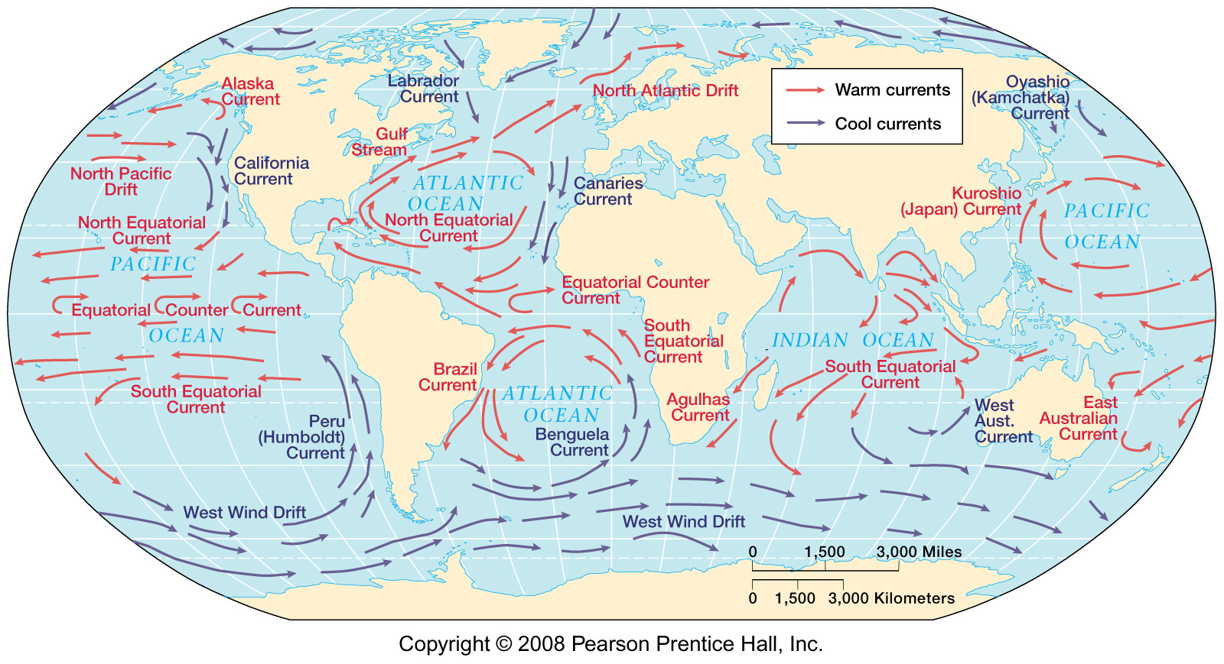

*Using figures 1 and 2:*

1. Is the temperature contrast between the equator and the Arctic region greatest in winter or summer?

During the Winter.

1. Were latitude the only control on temperature, the isotherms would run straight across the maps from east to west. Describe an area of the earth where you can observe this pattern with the isotherms. Why is the pattern seen here?

Down in the waters above the Antarctic landmass you can observe these patterns mostly because there are no land masses to break up the winds and currents traveling from west to east

1. Is the influence of cool ocean currents on coastal temperatures more pronounced in summer or winter? Why?

In the Summer, because the cool currents make the isotherm curve around the coast such as on the west coast of South America and west coast of africa

1. Comparing the January map with the July map, describe one region of the world that exhibits a large annual temperature range (the difference between the January and July average temperatures).

What explains the large annual temperature range?

The north eastern part of Russia is where I see the largest change and the reason is that it is relatively land locked and there are no warm currents

1. Describe one region of the world that exhibits a small annual temperature range. What explains this small annual temperature range.

The equatorial regions have a small annual temperature range, the mix of warm and cold currents provide for a balanced temperature variation

1. Consider you are to draw a line straight across the July temperature map, starting where the 60 degree Fahrenheit isotherm (16 degree Celsius) reaches the left edge of the map (west of our region in the Pacific Ocean) and ending where that same 60 degree Fahrenheit (16 degrees C) isotherm reaches the right edge of the map. A hypothetical horizontal straight line isotherm pattern would imply no land-water contrasts, ocean currents, and so on.

Compare the 60 degrees Fahrenheit (16 degrees C) isotherm on the map with your hypothetical straight line. In places where the actual 16 degrees C is south of the hypothetical line, temperatures are lower than expected. In places where the actual 16 degrees C isotherm is north of the hypothetical line, temperatures are higher than expected.

As you move along the line across the map from west to east, explain the specific deviations of the 16 degrees C isotherm from the hypothetical straight line.

So when it hits North American west coast which causes it to rise in temp due to the land mass heating the area and even when it hits the atlantic it maintains the warmer temp until it hits europe and then gains more temperature and gets carried through the asian continent and then gets cooled off by the Oyashio current as it moves toward the North American continent again.